
National University of Sciences & Technology (NUST) Balochistan Campus (NBC), Department of Computer Science
Department of Computing
CS-250: Data Structure and Algorithms
Class: BSCS
Lab 8: Implementation of Sorting Algorithms and Complexity Analysis
Date: 27th November, 2024
Time: 10 pm - 1 pm
Lab engr: Safder Ali

NAME | SAMEER TALREJA
CMS | 457795
DEPARTMENT | COMPUTER SCIENCE
SEMESTER | 3RD

CS250: Data Structures and Algorithms Page 1

National University of Sciences & Technology (NUST) Balochistan Campus (NBC), Department of Computer Science
Lab 8: Implementation of Sorting Algorithms and Complexity Analysis
Introduction
In this lab, you will implement three sorting algorithms and compare them. Objectives
Objective of this lab is to implement insertion sort and merge sort and compare the running times for both sorting algorithms.
Tools/Software Requirement
Visual Studio C++
Helping Material
Lecture slides, text book
Description:
Bubble Sort:
Insertion sort is a popular sorting algorithm, which is quite simple to implement. The pseudo code is as follows:
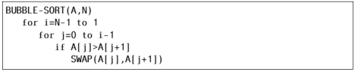
Selection Sort:
Selection sort is a popular sorting algorithm, which is quite simple to implement. The pseudo code is as follows:
CS250: Data Structures and Algorithms Page 2

National University of Sciences & Technology (NUST) Balochistan Campus (NBC), Department of Computer Science
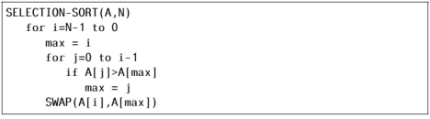
Insertion Sort:
Insertion sort is a popular sorting algorithm, which is quite simple to implement. The pseudo code is as follows:
Lab Tasks
Task 1:
Implement Bubble sort, Selection sort, Insertion sort algorithms in C++.
Task 2 (average case complexity):
The next step is to compare the two algorithms. Generate arrays of random numbers in the range 1 to 100 with sizes 100, 1000, 10000, 100000, and 1000000. Compare the running times of the three algorithms on each array. How do they compare? Are the results what you expected, and why? Answer the questions in the solution section.
Task 3 (best and worst case complexity):
Now sort the arrays using stl::sort, once in ascending order and then in descending order. Given both sorted arrays as inputs to all three algorithms and compute their running time. The running time of which algorithm shows most variations based on the structure of the input and why? Answer the questions in the solution section.
CS250: Data Structures and Algorithms Page 3

National University of Sciences & Technology (NUST) Balochistan Campus (NBC), Department of Computer Science
Important Note: Practice your knowledge of OOP with C++ when creating a solution. Remember to comment your code properly. Inappropriate or no comment may result in deduction of marks.
Solution:
Solution
Task 1:

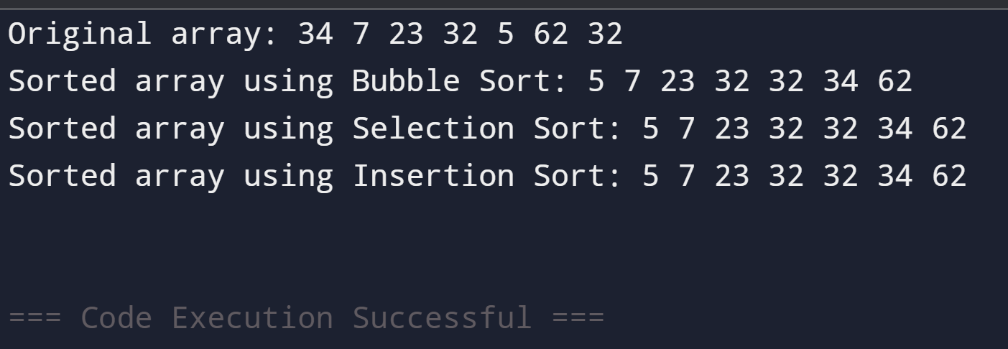

Task 2 :

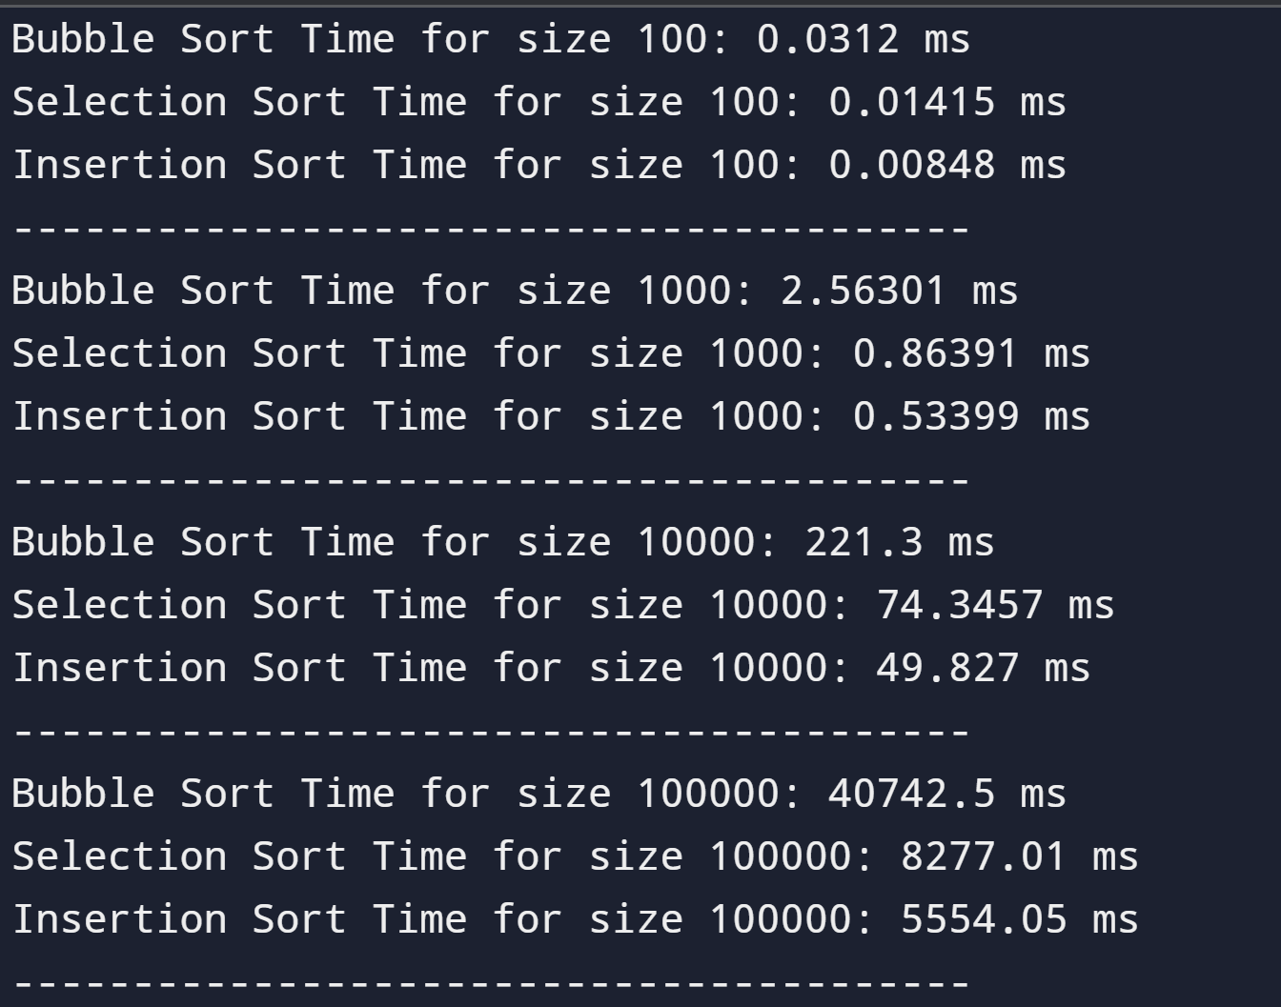

Task 3:

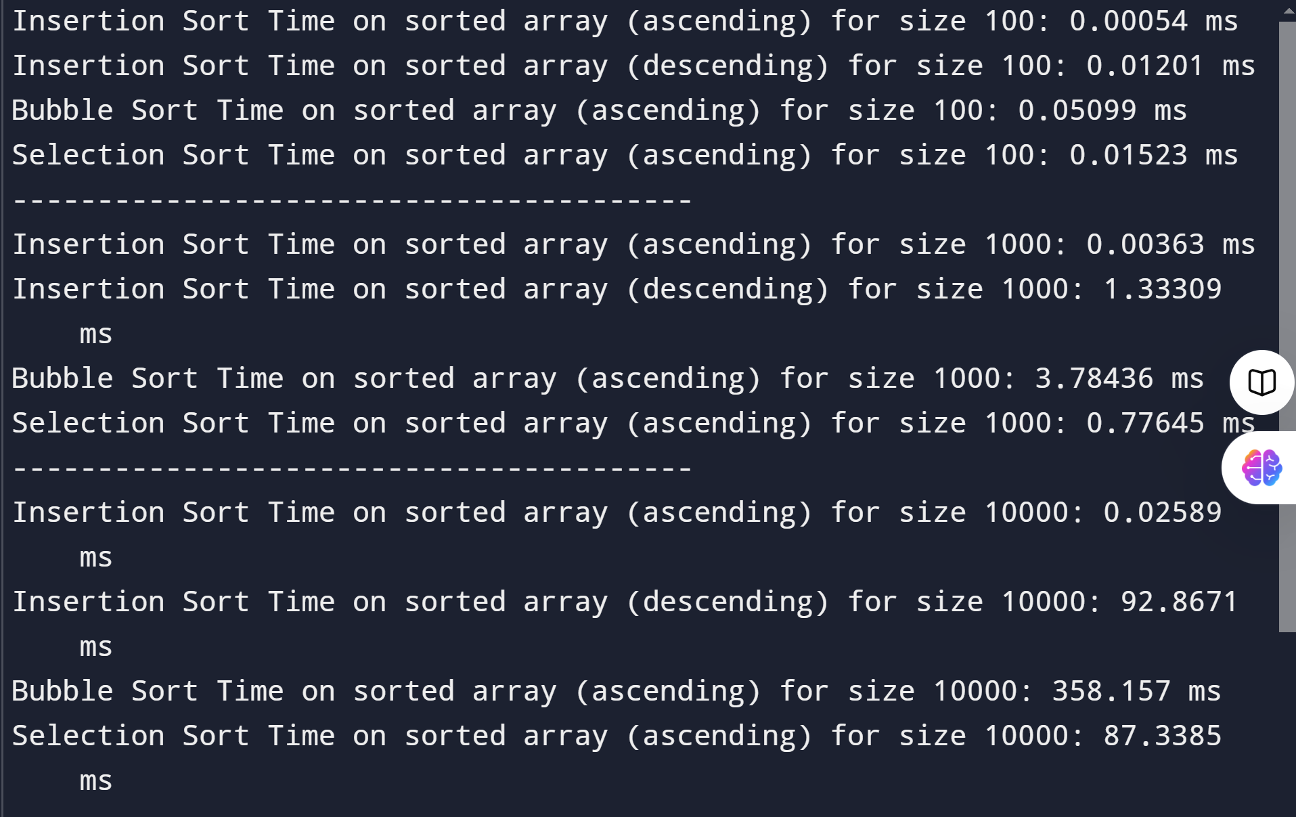
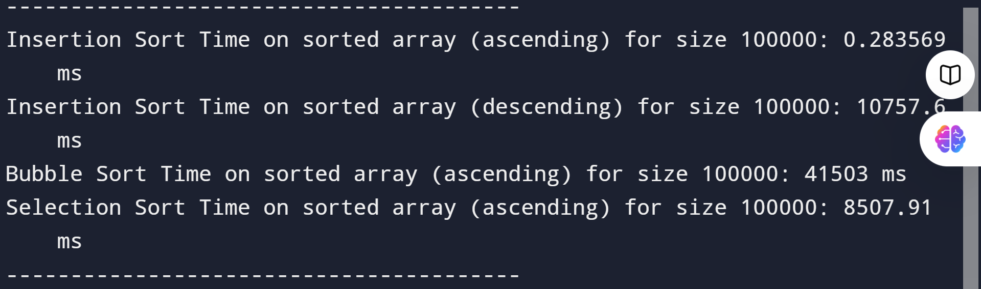

Expected Results:
- Insertion Sort: It performs well on sorted arrays, especially in ascending order, as its best-case complexity is O(n). However, it will show poor performance on the descending sorted array due to its O(n^2) complexity in the worst case.
- Bubble Sort: Similar to Insertion Sort, it will perform better on sorted arrays but will still be inefficient on larger sizes due to its O(n^2) complexity.
- Selection Sort: It will have consistent performance regardless of the input order, as its complexity remains O(n^2) in all cases.

Conclusion:
The running time of Insertion Sort shows the most variation based on the structure of the input. It performs exceptionally well on already sorted arrays (ascending) but degrades significantly on reverse-sorted arrays (descending). This behavior is due to the nature of the algorithm, which relies on shifting elements to insert the current key in its correct position. In contrast, Bubble Sort and Selection Sort do not benefit from sorted input and maintain their O(n^2) performance regardless of the input order.

Task 1 Code:

#include <iostream>

using namespace std;

class Sorter {
private:
int* arr;
int size;

public:
// Constructor to initialize the array
Sorter(int* inputArr, int arrSize) {
this-> size = arrSize;
this->arr = new int[size];
for (int i = 0; i < size; i++) {
arr[i] = inputArr[i];
}
}

// Destructor to free allocated memory
~Sorter() {
delete[] arr;
}

// Bubble Sort
void bubbleSort() {
for (int i = 0; i < size - 1; i++) {
for (int j = 0; j < size - i - 1; j++) {
if (arr[j] > arr[j + 1]) {
swap(arr[j], arr[j + 1]);
}
}
}
}

// Selection Sort
void selectionSort() {
for (int i = 0; i < size - 1; i++) {
int minIndex = i;
for (int j = i + 1; j < size; j++) {
if (arr[j] < arr[minIndex]) {
minIndex = j;
}
}
swap(arr[i], arr[minIndex]);
}
}

// Insertion Sort
void insertionSort() {
for (int i = 1; i < size; i++) {
int key = arr[i];
int j = i - 1;
while (j >= 0 && arr[j] > key) {
arr[j + 1] = arr[j];
j--;
}
arr[j + 1] = key;
}
}

void printArray() {
for (int i = 0; i < size; i++) {
cout << arr[i] << " ";
}
cout << endl;
}
};

int main() {

int arr[7] = {34, 7, 23, 32, 5, 62, 32};

Sorter sorter(arr, 7);

cout << "Original array: ";
sorter.printArray();

sorter.bubbleSort();
cout << "Sorted array using Bubble Sort: ";
sorter.printArray();

Sorter sorter2(arr, 7);
sorter2.selectionSort();
cout << "Sorted array using Selection Sort: ";
sorter2.printArray();

Sorter sorter3(arr, 7);
sorter3.insertionSort();
cout << "Sorted array using Insertion Sort: ";
sorter3.printArray();

return 0;
}

Task 2 Code:

#include <iostream>
#include <cstdlib>
#include <ctime>
#include <algorithm>
#include <chrono>

using namespace std;

// Bubble Sort
void bubbleSort(int* arr, int n) {
for (int i = 0; i < n - 1; i++) {
for (int j = 0; j < n - i - 1; j++) {
if (arr[j] > arr[j + 1]) {
swap(arr[j], arr[j + 1]);
}
}
}
}

// Selection Sort
void selectionSort(int* arr, int n) {
for (int i = 0; i < n - 1; i++) {
int minIndex = i;
for (int j = i + 1; j < n; j++) {
if (arr[j] < arr[minIndex]) {
minIndex = j;
}
}
swap(arr[i], arr[minIndex]);
}
}

// Insertion Sort
void insertionSort(int* arr, int n) {
for (int i = 1; i < n; i++) {
int key = arr[i];
int j = i - 1;
while (j >= 0 && arr[j] > key) {
arr[j + 1] = arr[j];
j--;
}
arr[j + 1] = key;
}
}

// Function to generate random array
int* generateRandomArray(int size) {
int* arr = new int[size];
for (int i = 0; i < size; i++) {
arr[i] = rand() % 100 + 1; // Random numbers between 1 and 100
}
return arr;
}

template <typename Func>
double measureTime(Func func, int* arr, int n) {
auto start = chrono::high_resolution_clock::now();
func(arr, n);
auto end = chrono::high_resolution_clock::now();
return chrono::duration<double, milli>(end - start).count();
}

int main() {
srand(time(0));

int sizes[] = {100, 1000, 10000, 100000, 1000000};

for (int size : sizes) {
int* arr = generateRandomArray(size);

int* arr1 = new int[size];
copy(arr, arr + size, arr1);
double bubbleTime = measureTime(bubbleSort, arr1, size);
cout << "Bubble Sort Time for size " << size << ": " << bubbleTime << " ms" << endl;
delete[] arr1;

int* arr2 = new int[size];
copy(arr, arr + size, arr2);
double selectionTime = measureTime(selectionSort, arr2, size);
cout << "Selection Sort Time for size " << size << ": " << selectionTime << " ms" << endl;
delete[] arr2;

int* arr3 = new int[size];
copy(arr, arr + size, arr3);
double insertionTime = measureTime(insertionSort, arr3, size);
cout << "Insertion Sort Time for size " << size << ": " << insertionTime << " ms" << endl;
delete[] arr3;

delete[] arr;
cout << "----------------------------------------" << endl;
}

return 0;
}

Task 3 Code:

#include <iostream>
#include <cstdlib>
#include <ctime>
#include <algorithm>
#include <chrono>

using namespace std;

// Bubble Sort
void bubbleSort(int* arr, int n) {
for (int i = 0; i < n - 1; i++) {
for (int j = 0; j < n - i - 1; j++) {
if (arr[j] > arr[j + 1]) {
swap(arr[j], arr[j + 1]);
}
}
}
}

// Selection Sort
void selectionSort(int* arr, int n) {
for (int i = 0; i < n - 1; i++) {
int minIndex = i;
for (int j = i + 1; j < n; j++) {
if (arr[j] < arr[minIndex]) {
minIndex = j;
}
}
swap(arr[i], arr[minIndex]);
}
}

// Insertion Sort
void insertionSort(int* arr, int n) {
for (int i = 1; i < n; i++) {
int key = arr[i];
int j = i - 1;
while (j >= 0 && arr[j] > key) {
arr[j + 1] = arr[j];
j--;
}
arr[j + 1] = key;
}
}

// Function to generate random array
int* generateRandomArray(int size) {
int* arr = new int[size];
for (int i = 0; i < size; i++) {
arr[i] = rand() % 100 + 1; // Random numbers between 1 and 100
}
return arr;
}

template <typename Func>
double measureTime(Func func, int* arr, int n) {
auto start = chrono::high_resolution_clock::now();
func(arr, n);
auto end = chrono::high_resolution_clock::now();
return chrono::duration<double, milli>(end - start).count();
}

int main() {
srand(time(0));

int sizes[] = {100, 1000, 10000, 100000, 1000000};

for (int size : sizes) {
int* arr = generateRandomArray(size);

sort(arr, arr + size);

int* arr1 = new int[size];
copy(arr, arr + size, arr1);
double insertionSortedTime = measureTime(insertionSort, arr1, size);
cout << "Insertion Sort Time on sorted array (ascending) for size " << size << ": " << insertionSortedTime << " ms" << endl;
delete[] arr1;

for (int i = 0; i < size / 2; i++) {
swap(arr[i], arr[size - i - 1]);
}
int* arr2 = new int[size];
copy(arr, arr + size, arr2);
double insertionSortedDescTime = measureTime(insertionSort, arr2, size);
cout << "Insertion Sort Time on sorted array (descending) for size " << size << ": " << insertionSortedDescTime << " ms" << endl;
delete[] arr2;

int* arr3 = new int[size];
copy(arr, arr + size, arr3);
double bubbleSortedTime = measureTime(bubbleSort, arr3, size);
cout << "Bubble Sort Time on sorted array (ascending) for size " << size << ": " << bubbleSortedTime << " ms" << endl;
delete[] arr3;

int* arr4 = new int[size];
copy(arr, arr + size, arr4);
double selectionSortedTime = measureTime(selectionSort, arr4, size);
cout << "Selection Sort Time on sorted array (ascending) for size " << size << ": " << selectionSortedTime << " ms" << endl;
delete[] arr4;

delete[] arr;
cout << "----------------------------------------" << endl;
}

return 0;
}

Deliverables
Compile a single word document by filling in the solution part and submit this Word file on LMS. This lab grading policy is as follows: The lab is graded between 0 to 10 marks. The submitted solution can get a maximum of 5 marks. At the end of each lab or in the next lab, there will be a viva related to the tasks. The viva has a weightage of 5 marks. Insert the solution/answer in this document. You must show the implementation of the tasks in the designing tool, along with your complete Word document to get your work graded. You must also submit this Word document on the LMS / google class room. In case of any problems with submissions on LMS, submit your
Lab assignments by emailing it to Safder Ali: students.em96@gmail.com.
CS250: Data Structures and Algorithms Page 4

